Views

The user login:

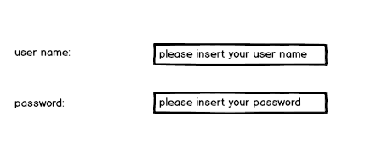

Change information for a customer (looks the same as for the rest of the changable fields only difference is that the values and att differs.):

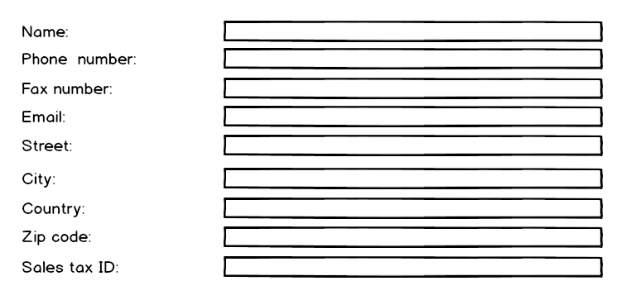

Adding destination:

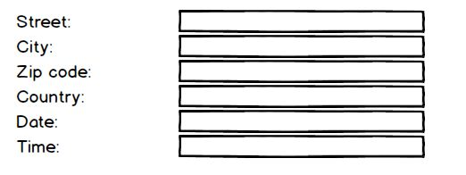

View for overviewing information, looks the same for drivers, trucks, trailers and customers.(only with different attributes.)

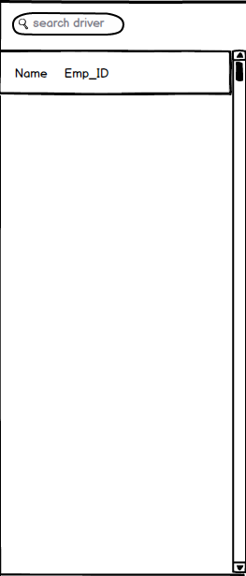

Adding a new driver, this looks the same for adding other entities listed above (of course again with different att.)

